16.write a python program to sum integers from 1 to n
Aim
To write a Python program to calculate the sum of integers from 1 to n.

Algorithm
- Read the value of n.
- Initialize sum = 0.
- Repeat from 1 to n.
- Add each number to the sum.
- Display the result.

Python Program
n = int(input("Enter the value of n: "))
sum = 0
for i in range(1, n + 1):
sum += i
print("Sum =", sum)
Sample Input
Enter the value of n: 10
Sample Output
Sum = 55
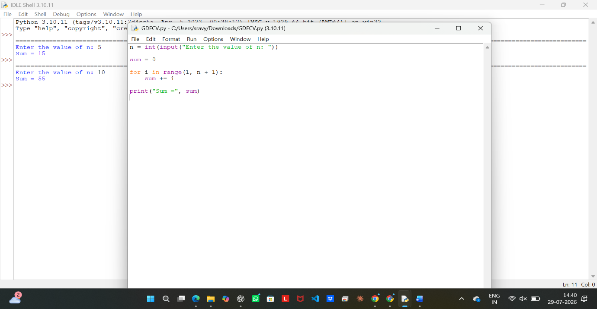

Result
Thus, the sum of integers from 1 to n was calculated successfully.

